CaravanSalon_Logo_01_4C.epsDear camping enthusiasts,

We want to point out that there is another overnight car park for camping vehicles. This car park is operated by the Unterrath shooting club. **The cost is EUR 15.00 per day.**

To get to the trade fair, you can take bus number 730 (trip takes 10 minutes) or ride a bicycle (about 20 minutes).

A bakery, restaurants, etc. are just 250 m away on Unterrather Strasse.

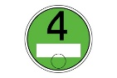

You need a to drive onto the car park!

Best wishes from Messe Düsseldorf

VEHICLE ACCESS is only possible via Kieshecker Weg 153!

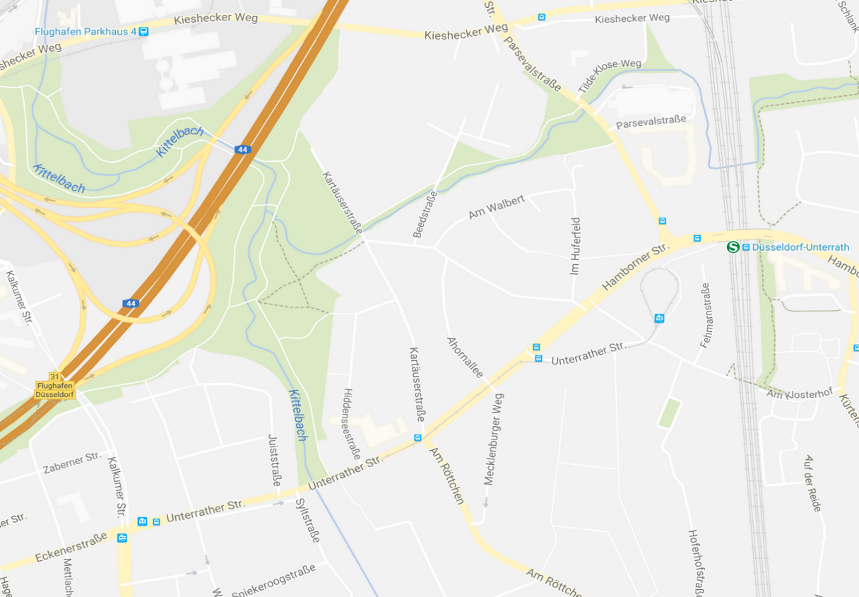







730



Datei:Verbot einer Fahrtrichtung oder Einfahrt.png

Datei:Verbot einer Fahrtrichtung oder Einfahrt.png

Datei:Verbot einer Fahrtrichtung oder Einfahrt.png

**To get to the camping site, enter the following address into your satnav: Kieshäcker Weg 153, 40468 Düsseldorf.**

CaravanSalon_Logo_01_4C.eps

Dear camping enthusiasts,

We want to point out that there is another overnight car park for camping vehicles. This car park is operated by the Rath shooting club. **The cost is EUR 15.00 per day.**

To get to the trade fair, you can take bus number 730 (trip takes 15 minutes) or ride a bicycle (about 30 minutes).

Bakeries, restaurants, etc. are close by.



You need a to drive onto the car park!

Best wishes from Messe Düsseldorf

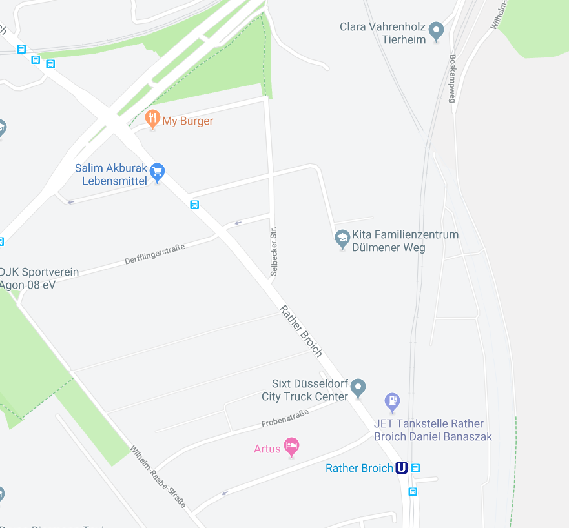



**To get to the camping site, enter the following address into your satnav:   
Rather Broich 137, 40472 Düsseldorf.**

CaravanSalon_Logo_01_4C.eps

Dear camping enthusiasts,

We want to point out that there is another overnight car park for camping vehicles. This car park is provided by the Lohausen shooting club.

**The cost is EUR 20.00 per day.**

To get to the trade fair, you can ride a bicycle (trip takes about 10 minutes).

Bakeries, restaurants, etc. are close by.



You need a to drive onto the car park!

Best wishes from Messe Düsseldorf

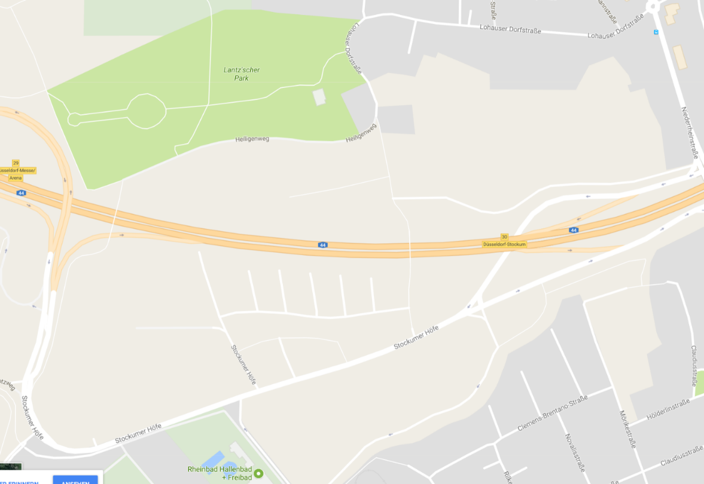

P22

P12

**To get to the camping site, enter the following address into your satnav: Lohausener Dorfstrasse 16, 40474 Düsseldorf**